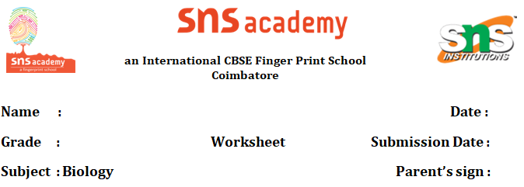

FUNDAMENTAL UNIT OF LIFE
1. Identify the image and label the following
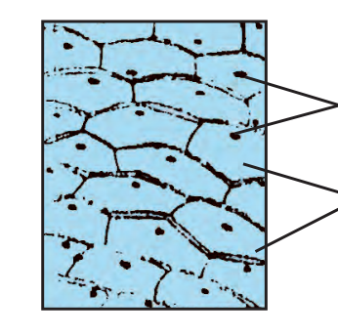
a) Cells of a tomato peel; Nucleus, Cells. b) Cells of an onion peel; Nucleus, Cells.
c) Cells of a potato peel; Nucleus, Cells. d) Cells of a garlic peel; Nucleus, Cells.

2. Many cells group together in a single body and assume different functions in it to form various body parts in _________ .
a) Unicellular b) Multicellular c) Both a and b d) None of these
3. Identify the cell from the human body.
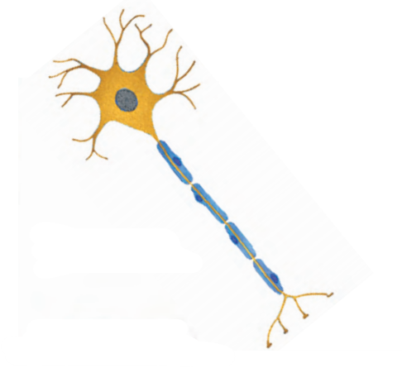
a) Nerve cell b) Smooth muscle cell c) Ovum d) Fat cell
4. The diagram shows an animal cell with some of its organelles. X is also a cell organelle. What does X represent in the diagram?
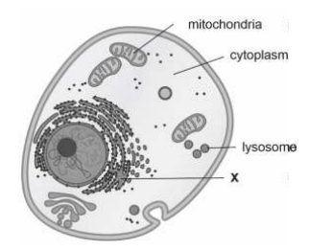
a) Nucleus b) Chromosome
c) Golgi apparatus d) Endoplasmic reticulum
5. Cells grow by dividing. The picture shows one such growing cell ready to divide. How many cells will be formed after the cell divides completely?
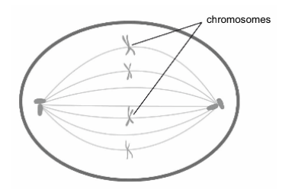

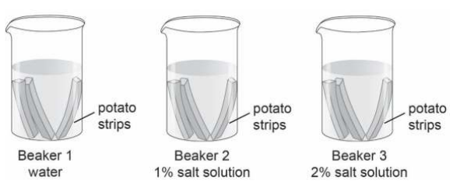
6. Sania conducts an experiment to know how plant cells lose or gain water through osmosis. She cuts out 5 cm long potato strips. She puts three potato strips in each of the following beakers: Beaker 1 containing only water Beaker 2 containing 1% salt solution Beaker 3 containing 2% salt solution Sania leaves the potato strips in the beaker for 5 hours. She records the length of the potato strips in each beaker after 5 hours.

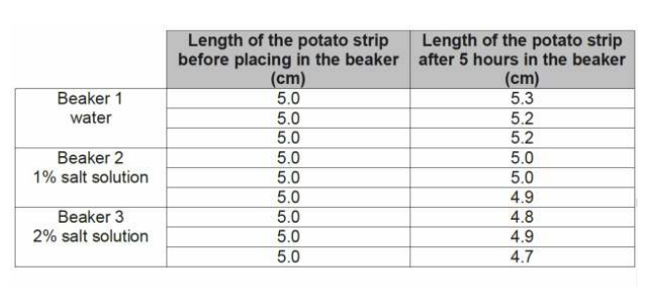

(i) What can Sania conclude from her experiment?
a) Salt molecules from the cell move out when kept in water.
b) Cells gain water through osmosis when kept in salt solution.
c) Cells in salt solution first gain water and then gradually lose water.
d) Water molecules move out of the cell based on the amount of salt in the solution.
7. What property of the plasma membrane helps amoeba acquire food?
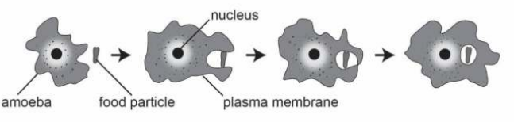
a) It is flexible.
b) It is selectively permeable.
c) It is made up of proteins and lipids.
d) It allows diffusion of some substances across it.
8. A cell division is the process by which new cells are formed. It is of two main types:Mitosis and meiosis. Meiosis is only confined to specific cells called meiocytes of reproductive organs or tissues in animals, plants, various protists and fungi. It takes place at a particular time.These specific cells divide to form gametes.Mitosis, on the other hand,occurs in all kinds of cells and continues throughout life.
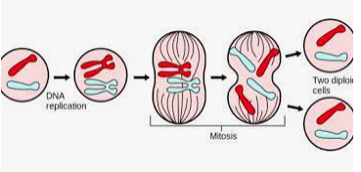
(i) How many daughter cells are formed in meiosis?
a) 4 b) 3 c) 2 d) none of the above
(ii) Which of the following divisions is also termed as somatic division?
a) meiosis b) mitotic c) both a and b d) none of the above
(iii) Which among the following is called reduction cell division?
a) meiosis b) mitosis c) both a and b d) none of the above
(iv) Mitosis has how many distinct phases?
a) 4 b) 3 c) 5 d) none of the above
(v) In which cell division, number of chromosomes become halved?
a) meiosis b) mitosis c) both a and b d) none of the above
9. Observe the diagram and answer the following questions
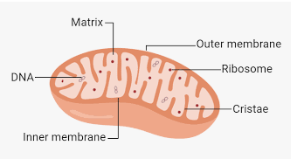

It generates most of the cell's supply of adenosine triphosphate, used as a source of chemical energy.
(i) Which of the following has their own DNA and ribosomes?
a) Mitochondria b) Plastid c) Both A and B d) None of these
(ii) This is the figure of?
a) Plastid b) Mitochondria c) Golgi bodies d) None of these
(iii) Why is its inner membrane folded?
a) To increase surface area for exchange of gases
b)To increase surface area for absorption of food
c) To increase surface area for filtration of blood
d) To increase surface area for production of energy
(iv) In which of the following organism above organelle is not present
a) Bacteria b) Plants c) Animals d) Fungi
(v) This is also called?
a) Brain of the cell b) Powerhouse of the cell
c) Kitchen of the cell d) None of these

